Immigration and Our Communities

Here are some things that are helpful to know, according to the National Immigration Project:
- ICE can only arrest people in private spaces if they have a judicial warrant or if they are given consent to enter. Almost always they will only have an administrative warrant. This is an administrative warrant. It is issued by the Dept. of Homeland Security, and it is signed by an immigration officer. Arrests can be made in public with an administrative warrant but not in private.

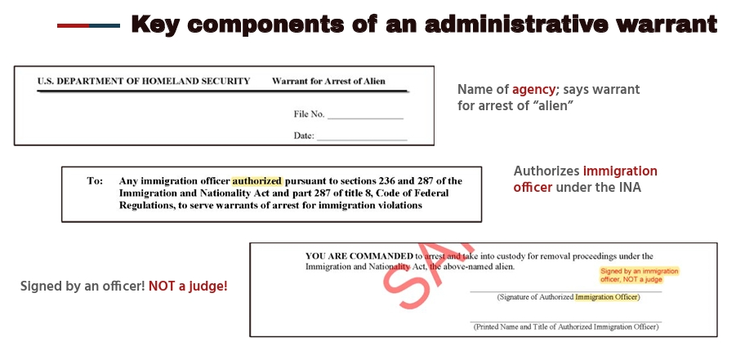

- This is a judicial warrant. It comes from a court; it is signed by a judge and is dated. It must be used within two weeks of the date. ICE must have a judicial warrant to come into a private area or your consent.

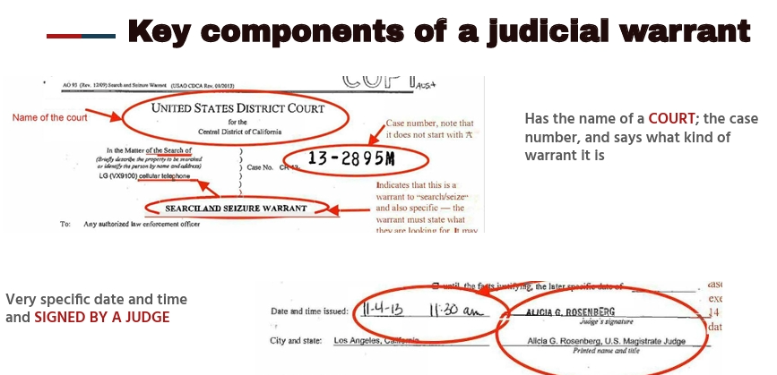

- Your home is a private space. The interior of your car is private. Areas for “employees only” at work are private – for example a break room or an office. Areas marked as “private” in churches are private – put signs on the door to designate these spaces as private – for example the pastor’s office or the room where communion is prepared. Most K-12 schools are private. Hospital exam rooms and offices are private. Without a judicial warrant or consent ICE cannot enter these spaces.
- ICE will almost never have a judicial warrant. Avoid giving consent. Do not open your door if you are at home. Employers, school officials, and church officials can also refuse to allow ICE to enter unless they show a judicial warrant. Look closely at the warrant. If it is an administrative warrant from the Dept. of Homeland Security, and not from a court, you do not have to allow them to enter.
- If you see ICE making an arrest, video-record it on your phone. You cannot interfere with the arrest, but it is legal to take a video of it. If you can’t film it, write down everything you see immediately.
- Parking lots are public spaces and people are vulnerable to arrest going in and out of church or work or dropping or picking up children from school. Consider escorting people into the church and being ready to film an arrest that is made.
- Together we can make sure that ICE respects the rights of all people. We cannot stop every arrest or deportation. Encourage people to prepare for possible deportation. Here is a guide put out by our denomination that may be helpful.

Preparation Plan
For members at risk of deportation and
the congregations who support them

Some Presbyterians and local community members lack lawful immigration status or are under a temporary status that may not be renewed. They live in fear of being detained and deported by immigration officials. As Presbyterians, we are led by the standards of the great ends of the church in the Book of Order, one of which is to strive for “the shelter, nurture, and spiritual fellowship of the children of God ...” (F-1.0304). Here is a link to resources from our denomination that families can use to prepare for possible deportation: Family Care Plan | Presbyterian Church (U.S.A.)

The following link contains information about "red cards" and a site where they can be ordered:
Know Your Rights Cards | redcardorders.com | Immigrant Rights Cards

National Immigration Project https://nipnlg.org/

This information is from the Valley Bridge, February 12, 2025, Presbytery of Minnesota Valleys.

