You are a part of a church
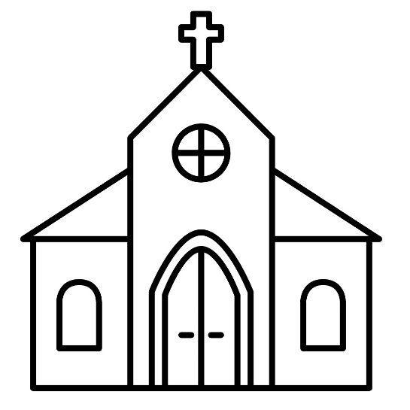
And a part of a Presbytery!
And a part of the Synod of Lakes and Prairies! Put a star where you are on this map.
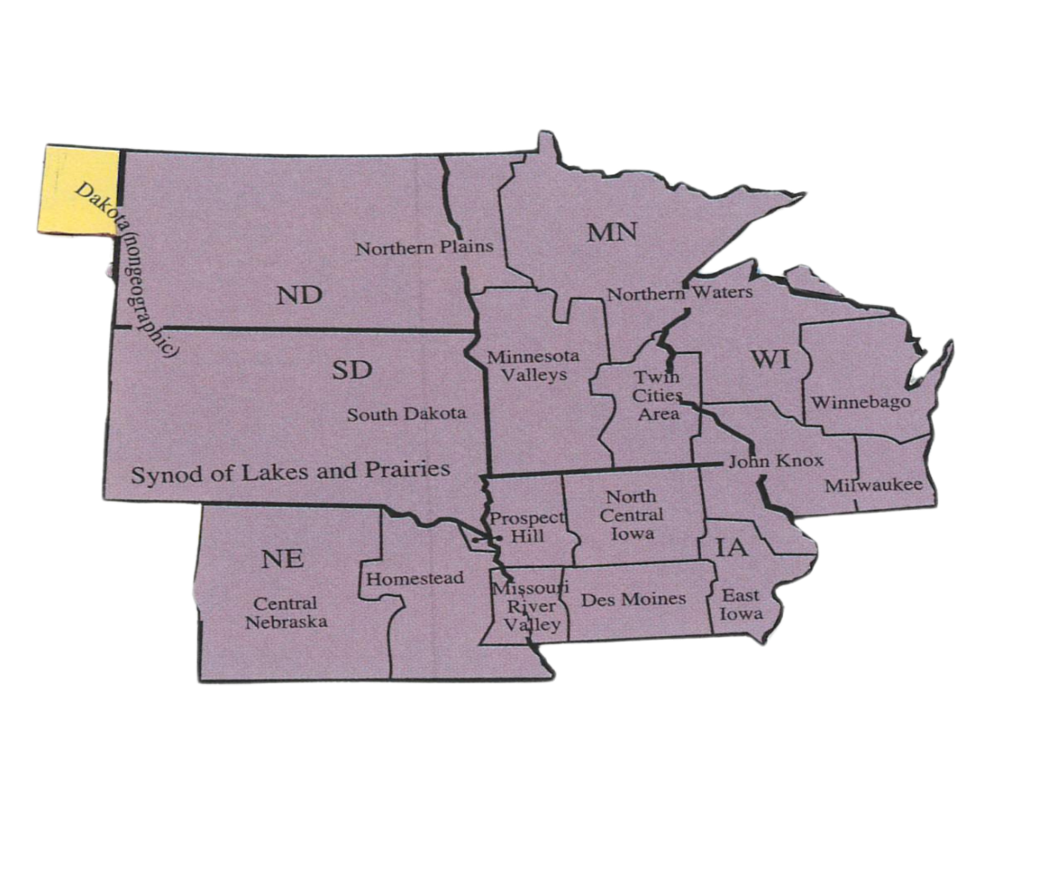
Synod Sunday 2025
Children’s
Worship Bulletin

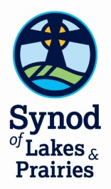

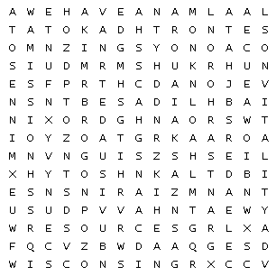

Fun |  | Grants |  | Iowa | Wisconsin
Leaders |  | Learning |  | Minnesota
Mission |  | Nebraska |  | North Dakota
Resources |  | Scholarships |  | Vitality
South Dakota |  | Synod School |  | Training

___ ___ ___ ___ ___ ___ ___ ___ ___ ___ ___ ___ ___ ___
___ ___ ___ ___ ___

This puzzle is a word search puzzle that has a hidden message in it. First find all the words in the list. Words can go in any direction and share letters as well as cross over each other.
Once you find all the words. Copy the unused letters starting in the top left corner into the blanks to reveal the hidden message.

The Synod has six states. Can you name them from the puzzle?

Look at the front cover… See if you can find these symbols of our Synod:
Cross Sun Water flowing Plants growing
**************************************************************
We have over 700 churches and over 73,000 people!
Imagine what we can do together!

