Coaches in Training
The following coaches are available to provide coaching to members of the Synod at a significantly reduced cost. Those who are listed here have shared information to help you select a coach. It is highly recommended that you schedule an initial 30-minute session to determine whether or not there is a “fit” with the coach. They are equipped to lead this session to explore coaching for you.

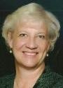
Deb DeMeester
Contact Information ddemeester@lakesandprairies.org
Coach-in-training with the International Coaching Federation
I serve the Synod of Lakes and Prairies as the Director of Leadership
Development. In my own life, coaching has been a tremendous gift, helping me to live and work out of my strengths and gifts in ways that have been very helpful. I love that coaching starts from the premise that each person is creative, resourceful and whole and find joy in empowering others through this process. I am looking forward to sharing this gift with others.

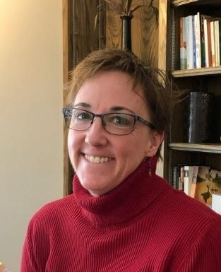
Becca Fletcher
Contact Information: becf22@gmail.com; Cell Phone (optional): 651-341-4185
International Coaching Federation Coach in Training
I am a retired hospital chaplain and enjoy working with people who serve in non-parish-based ministry settings. I enjoy working with people who feel “stuck.” I have experience working in the areas of addiction, mental illness, gender, and sexuality.
I believe that every person wants to be healthy, happy, and whole, and that the brokenness of the world and of all of us humans in it can make finding and keeping health, happiness, and wholeness difficult. I believe that no person is defined by the struggles in their life despite the common tendency for people to define themselves that way (I’m depressed, I’m stuck, etc.). It is my mission to offer a compassionate, listening presence, an attitude of curiosity, a spirit of absolute acceptance, and a collaborative stance in addressing conflicts, problems, and struggles. Stories of difficulty and darkness can become overwhelming when faced alone, and the moments of resistance, of agency, of resilience, of power – the Sparkling Moments – can easily be lost or forgotten in the face of powerful negative narratives. Together, we will find the Sparkling Moments and explore how they provide evidence of and building blocks for the story of health, happiness, and wholeness.

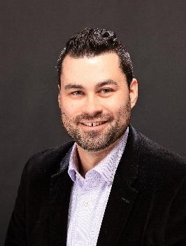
Michael Goodwin
Contact Information: Mike.goodwin@mpcappleton.org 920-224-3416

International Coaching Federation Coach in Training

I am Pastor and head of staff at Memorial Presbyterian Church in Appleton, WI. Through coaching, we discover the wisdom within us together. I believe it is a gift to share holy space with another person, so as a coach, I value safety, honesty, grace to show up as we are, and openness to being transformed along the way. Use this link to schedule a 30-minute conversation to see if coaching is right for you https://calendly.com/mike-goodwin

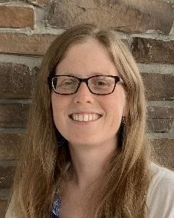
Kendra Grams
Contact Information: kendra.grams@fpchudson.net
International Coaching Federation coach in training
I serve as pastor of First Presbyterian Church in Hudson, Wisconsin. I enjoy empowering others to claim their God-given wholeness and wisdom through the coaching process. In addition to congregational ministry and coaching, I am passionate about collaborations for justice, and creative and playful opportunities to promote community flourishing. https://www.fpchudson.net/meet-our-staff/

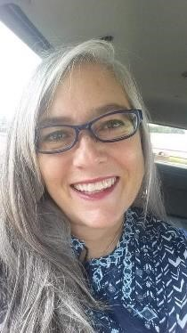
Kristin Hutson
Contact info:. kristin.e.hutson@gmail.com (319) 431.5701
Rev. Kristin Hutson, Teaching Elder (she, her, hers). In my coaching, I seek to walk alongside my clients as they discern what matters the most to them and who they are called to be. I hope my clients will feel empowered as they tap into their own wisdom, strength and potential. I work with clients of all ages, identities, backgrounds, and vocations.

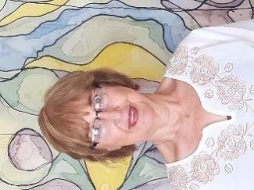
Melody Oltmann
Contact Informatipm: a.praise.song@gmail.com; Cell Phone (optional):
563.381.7777
Coach-in-training with the International Coaching Federation
Coaching allows me to offer an invitation to grow and trust oneself, as we journey together on a path to clarity and a-ha moments. I offer sacred listening and thoughtful questions which remind and help clients discover/rediscover their own resilience, creativity and answers.
I am a small church pastor in East Iowa, having served here for eleven years. I am the mother of four children, happily married for 46 years. Before seminary, I was a registered nurse, focused on safety, injury prevention and wellness for thirty plus years.

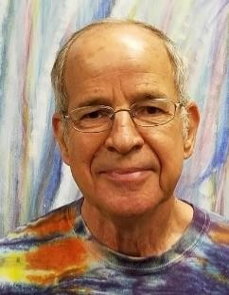
Paul Penn
Contact Information: papenn46@hotmail.com or Cell Phone: 605 951 4649
Coaching credentials: Coaching Training; Stephen Ministry Leader and Trainer
I enjoy walking along with individuals and small groups as they discover their passions, gain confidence in their strengths, and move forward. I especially enjoy the visioning process---exploring the big picture of what the future could be.

Ken Ribe
Contact Information: ken.ribe@gmail.com
Coach-in-training with the International Coaching Federation
I serve as Part-time Presbyter for Pastoral Care, for the Presbytery of Northern
Waters. I have served congregations in Central Nebraska, North Central Iowa, Twin Cities Area, North Dakota and Northern Waters. From 2007 until 2020 I have been involved in Interim Ministries in 8 congregations. Coaching is a wonderful gift and has helped me to identify, and live into my strengths for ministry. Coaching always begins with the premise that each of us have everything we need to make our lives work—coaching helps us to focus on those gifts so that we can maximize our potential.

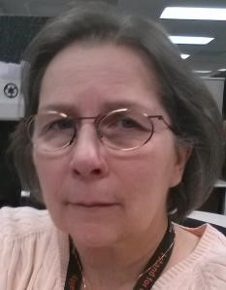
Michele Scott
Contact Information: mis1scott6520@gmail.com 319 721 5719
Coaching credentials: Coach-in-training with the International Coaching Federation
I am serving with Olivet Presbyterian Church in Cedar Rapids, Iowa as the pastor. I was ordained in 1984 and have served in churches and college chaplaincy in
Massachusetts, North Dakota and Iowa. I was a bi-vocational, part-time pastor from 1992 until my retirement from full-time employment with Collins Aerospace in 2018 as a engineering project manager and operations trainer. I appreciate coaching as it celebrates the gifts and the strengths that God gives to each of us.

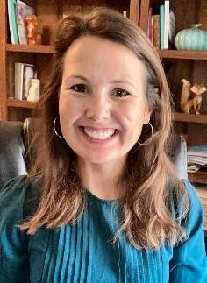
Elaine Sveet
Contact Information: elaine@chasingabundantlife.com; chasingabundantlife.com; 701-771-7906

ICF trained coach, BA in Psychology, Masters of Divinity, 18 years of ministry

Coaching is a major part of my current ministry with Chasing Abundant Life. I serve rural school staff in the Minot ND area with coaching services for mental health support, work and life balance, stress strategies, and self-care. I also serve coaching clients who are pastors, entrepreneurs, and leaders looking to work on specific professional goals or self-care. The coaching I offer is encouraging and equipping, with strategies to fit your goals and strengths.

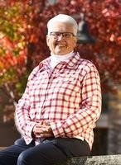
Judy Winkelpleck
Contact Information: judy.winkelpleck@gmail.com; or 515-314-3164
Sometimes being invited to insightful questions and discerned reflections can bring you comfort, wisdom, and excitement. If identifying issues and seeking your own inner guidance on issues--small and large--would help you enjoy life more, then coaching may be for you. I come to you with experiences as a corporate executive, non-profit leader, hospice chaplain, intentional interim pastor, and coach in training.

